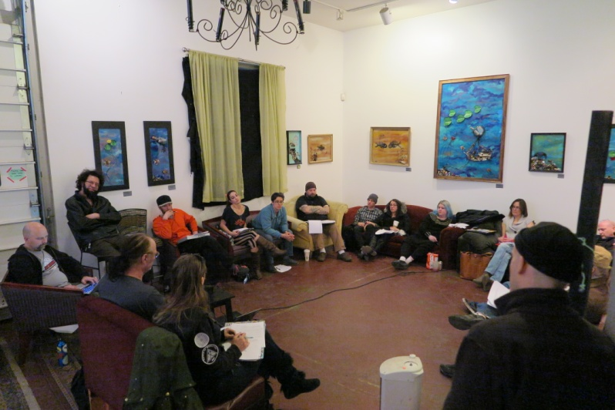
January 2016 Board meeting!
Hey guys! We had another lively board meeting! It’s nice to see so many people coming out to get involved!
There were numerous Public Comments about our BAMF crisis:
The Rangers need a timeline and feedback for other arms of the emergency services team. They are urging the Board of Directors to get a plan in place, sooner than later. There is a possible lead, however, and the board is requesting time to vet her appropriately. This is a big position and the Board wants to make sure that this is the right person for the job! The option of hiring outside medical staffing is still on the table, but as a last resort.
Please! We need BAMF Volunteers!!!
The Vice President’s report:
We are so excited to have land near Trinidad, but this leaves a lot of other things to take into consideration: there are water features and the ability to have multiple burn scars. Both bring benefits and hazards! The Board is working on establishing the Walden, CO property as a plan B, and Arapahoe Valley Ranch as a possible plan C.
Treasurer’s Report:
Budget updates! Black Swan account has $24,017, and the Operating Budget is $112,393. The financials team is hard at work looking for data. The only thing missing after hours and hours of hard work crunching data and going through everything with a fine toothed comb is the depreciation, and this should be completed soon.
Our Burning Man Regional Representative is urging us to get this together because this is required from BMHQ! The Board is fast at work getting our cancellation insurance. Our fearless Treasurer, Dana, has everything gathered and submission is imminent! Thank you so much! What would we do without her!?
So much to do! So little time!! Apogaea really needs all the help we can get to get everything together with the new land, new medical team, and pulling our resources that scattered after no event last year! Please volunteer! Enthusiastically participate! We need you!
Here is where you can find out about what volunteer positions are available and where volunteer form is located! DO IT!!
There is a major BAMF staffing drive underway:
The Board of Directors is beginning to look into contingency planning as a conservative way to protect Apogaea’s future! Hiring outside medical staffing is beginning to really look like a good idea. Despite the calls for BAMF volunteers, there has not been enough response! We are seriously looking to hire outside medical for higher medical coverage while still having a solid base of Apogaea BAMF volunteers for lower level support. This is an incredibly important department. We cannot risk not having this staffed adequately!!!
Please, Please, Please, Share this link far and wide! We are a big and awesome community! We must be able to find some help somewhere! Be a part of the solution!!!!

There is a lot of concern about the gas wells and land safety:
The owner’s testing records are being requested to assess safety. It has been suggested that fences could be put up to insure safety. Some volunteer opportunities could arise for the need to have these areas under supervision. Safety does not seem to be a huge issue with these very professionally maintained and utilized wells.
Our fearless President of the Board has released a statement about this very issue!!
There are other safety issues with the land, such as ravines and topographical issues. It was suggested that bridges could be built, trash fences could be utilized, and lights could be installed. This is a beautiful property with lots of amazing mountain views in the San Luis Valley; with different festival lands there are different issues to work around!
Ticket Pricing Discussion and Vote:
Unfortunately, there is not enough of a consensus to vote on this today. It was suggested that all emergency service volunteers earn tickets at no cost. The land lead states that, by his calculations, there are 40 acres of usable land. This could mean a 2,000 person event. There may be a need to reign in some of this land due to safety and neighborhood impact. A more comfortable population would probably be 1,500-1,750 people. However, the Board will not come up with a final decision until after the Ground Control Retreat.
Eric Moutz, previous board member of several years has stepped in to help with permitting and contracts on a temporary basis and will be giving assistance in attorney evaluation. Mike Lustig has stepped up, as well, to offer help with drafting contracts. Yay! Thanks so much guys! Your professional help is just what Apogaea needs to get this year going strong!
Ticket Prices have been determined!
Ticket Q & A
The Scholarship Tickets application has been released! Get on it! Thanks Board of Directors!

There were so many ratifications:
GO IGNITION!!!!
- Dana Deason is our new Volunteer Documentation Lead!
- Chris Wallace is our AMP Video Lead!
- Raina Farmer is our AMP Photo Lead!
- Gritty Kitty is our new Survival Guide Lead!!
- Jonathan Nickerson is our new LNT XXXO!!!
- Diane Overbye is our Gate XXXO!!!!
- Sasha Hurlock is our Youth Coordinator XXXO!!!!
- Michelle Meydenbuaer is the Grill Mistress XXXO!
- B.J. Noletti is the ICC Lead!!
- Kimistry Clinton is a Ranger Khaki!!

What an All-Star Group!!! Apogaea is so lucky to have you in our ranks and thank you so much for stepping up to make Apogaea awesome!

The Board has released information about how they are proposing to change the Ignition Ratification process and volunteer tickets! Check it out!

Ground Control Retreat is January 30th, 10 a.m.- 6 p.m. at Green Spaces. I can’t wait to hear how this turns out!! So many amazing minds under one roof! *goosebumps*
About Taylor….
The Board was forced to recognize the bylaw regarding three consecutive absences of a board member. He was effectively removed from the Apogaea Board. We are sorry to see him go, but bylaws are bylaws and need to be followed for Apogaea to run smoothly.
Can’t wait to see all of your sparkly faces at the next Board Meeting! It is going to be Sunday, Feb. 21, from 3 p.m. to 6 p.m. at the Fusion Factory in Denver!
Thanks so much, Meg, for letting all of us freaks use your awesome space!
So much art under one roof! No wonder the Community is feeling so inspired this year! Thanks, Fusion Factory!!

